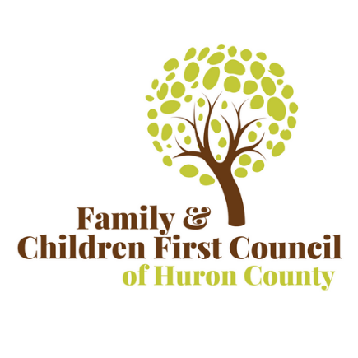
Family & Children First Council of Huron County
Meeting Agenda
Wednesday, March 30, 2022
Location: Virtual via Zoom

- Call to Order at 10:05
Voting Members:
X | Lenora Minor, HCDJFS |  | Kristen Cardone, HC Mental  Health and Addiction Services |  | Brad Cooley, Norwalk  City Schools
 | Dave Daniels, City of  Norwalk Police  Department | X | Mary Helton, Fisher-Titus  Medical Center |  | Tim Hollinger, Huron  County Public Health
 | Lindsey Kimball,  Parent Representative | X | Steve Burggraf, Family Life Counseling |  | Julie Westcott, Parent  Representative
 | Jeff Ritz, Willard City  Schools |  | Carol Robinson, Early  Intervention |  | Jennifer Tuttle, Parent  Representative
X | Kari Smith, HC Board of DD | X | Janice Warner, CAC  EHR/Head Start | X | Harry Brady, Huron  County Commissioner

Non-Voting Members:

 | John/Bethany Chime,  Clear Minds |  |  |  | Jamie Gfell/Bethany Lewis, Nord Center
X | Mary Valentine, Huron County CPS |  | Lonny Rivera |  | Angie Roth, Help Me  Grow
 | Sarah Simmons, ROY |  | Mary Valentine,  HCDJFS |  | Chris Mushett, Huron  County Juvenile Court  (Designee)
X | Lauren Robinson, Firelands Counseling  and Recovery |  | Beverly Turczyk  Department of  Youth Services

Staff:
X | Devin Pollick, Prevention  Coordinator | X | Niki Cross, FCFC  Director
 | Erin Whipple, Wraparound Facilitator

- Public Comment & Introductions
  - Devin Pollick, Prevention Coordinator

Motion 1 | Approval for submission of the RFI for SFY23 Funding for $88,500.00 from the Huron County Mental Health & Addiction Services Board for Prevention & Service Coordination purposes.
Motion Made By: | Harry Brady | Seconded: | Dr. Burggraf

X | Steve Burggraf, Family  Life Counseling |  | Kristen Cardone, HC Mental  Health and Addiction Services |  | Brad Cooley, Norwalk  City Schools
 | Dave Daniels, City of  Norwalk Police  Department - absent | X | Mary Helton, Fisher-Titus  Medical Center - absent |  | Tim Hollinger, Huron  County Public Health - absent
 | Lindsey Kimball,  Parent Representative |  | Lenora Minor, HCDJFS - abstain | X | Julie Westcott, Parent  Representative
 | Jeff Ritz, Willard City  Schools |  | Carol Robinson, Early  Intervention |  | Jennifer Tuttle, Parent  Representative
X | Kari Smith, HC Board of DD | X | Janice Warner, CAC  EHR/Head Start | X | Harry Brady, Huron  County Commissioner
Motion approved.
- New Business
  - Agency Updates
    - Huron County Board of DD is hosting the Bears vs Celebrities basketball game at Norwalk High School tonight at 6.
    - Janice Warner from CAC is asking for assistance filling out surveys. Niki will email the survey to the members.
    - Dr. Burggraf working on getting MRSS implemented.
    - Mary Valentine-April 13 is the Child Abuse Prevention walk. It starts at 9 am, and we will meet at Surr Park and end at the St. Paul’s social hall.

- Adjourn (Motion #2)
Motion 6 | Meeting Adjourn Approval
Motion Made By: | Dr. Burgraff | Seconded: | Lauren Robinson
Motion Approved. Meeting adjourned at 10:37 AM.
Next FCFC Meeting: May 18, 2022 @ 9:00 AM
Location: Huron County Board of DD

